# AI CODING

# ASSIGNMENT-4.4

# NAME:S.VRINDHA REDDY

# HALL NUMBER:2403A51255

# BATCH:11

# Task-1:

# Prompt:

Write a class definition comment and start the constructor for a class called Bank Account with  
account_holder and balance attributes

# Output:

# Task-2:

# Prompt:

Write a comment and the initial line of a loop to iterate over a list. Allow GitHub Copilot to  
complete the logic to sum all even numbers in the list.

# Output:

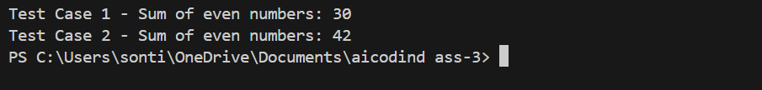

# Task-3:

# Prompt:

Start a function that takes age as input and returns whether the person is a child, teenager,  
adult, or senior using if-elif-else. Use Copilot to complete the conditionals

Output:

Task-4:

# Prompt:

Write a comment and start a while loop to reverse the digits of a number.

Output:

Task:5

# Prompt:

Begin a class Employee with attributes name and salary. Then, start a derived class Manager  
that inherits from Employee and adds department.

Output:

